Faiz Fazli
faiz.fazli@fmefamax.com
FAMAX QC SYSTEM
IPQC, IQC & OQC

Table of Contents
GENERAL USER GUIDE 2
USER GUIDE BY ROLE ACCESS 7
ENGINEER ACCESS 8
REGISTER ACCESS 11
PRODUCTION ACCESS 19

GENERAL USER GUIDE

- Enter Famax QC System by clicking this link http://192.168.0.5/FamaxQCSystem/index.html
- Main page will show as below image.
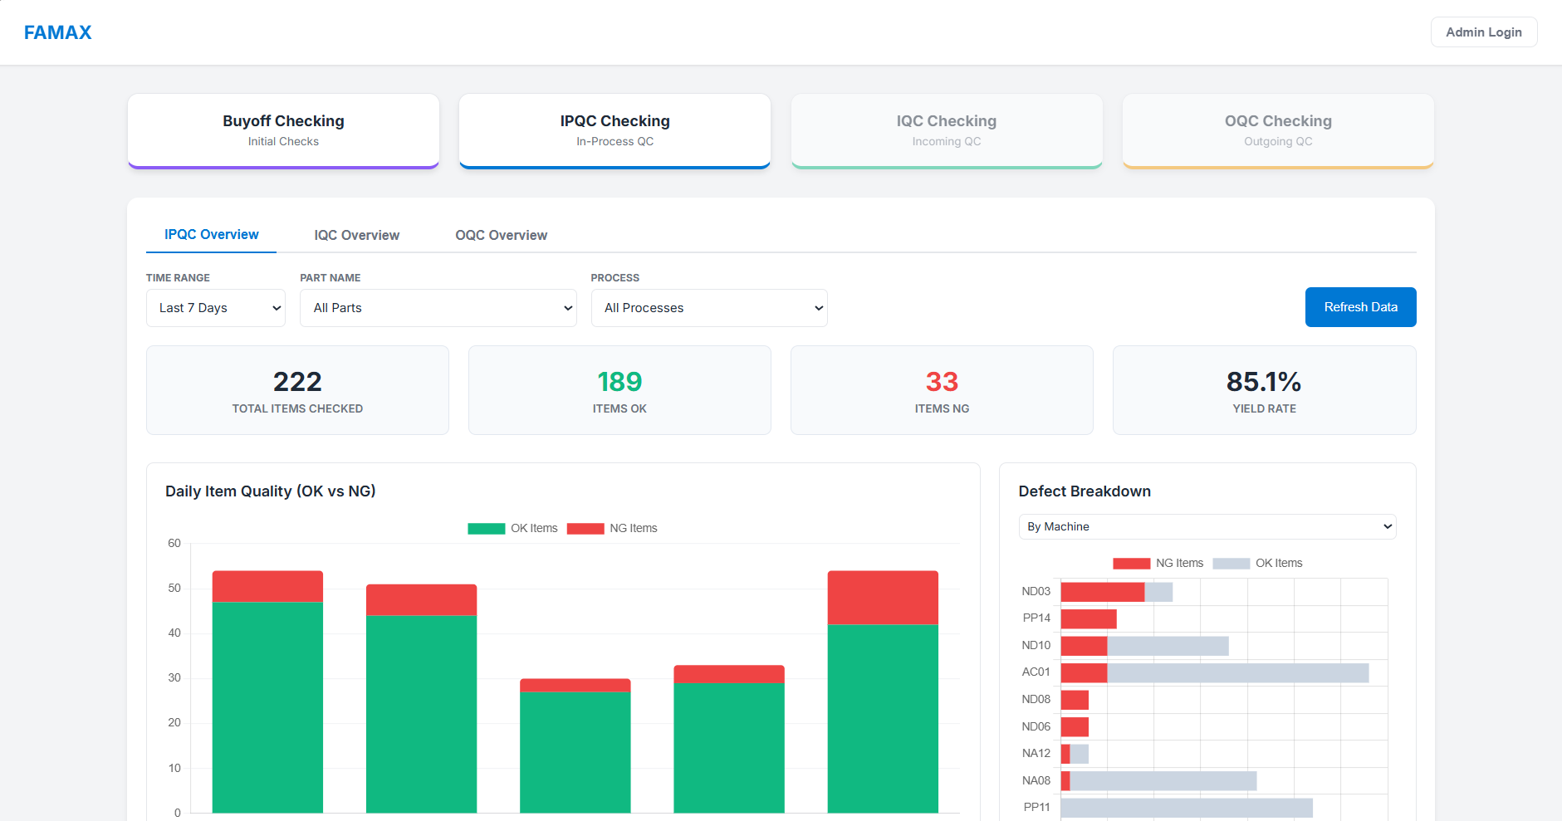
- The user can/only click the button in red box.

- When user performing
- Buy-Off – Then click “Buy-Off Checking” button.
- IPQC – Then click “IPQC Checking” button.
- IQC – Then click “IQC Checking” button.
- OQC – Then click “OQC Checking” button.
- The image shows what happens once “IPQC Checking” button is clicked.
  - First you must select Part Name from the dropdown box.
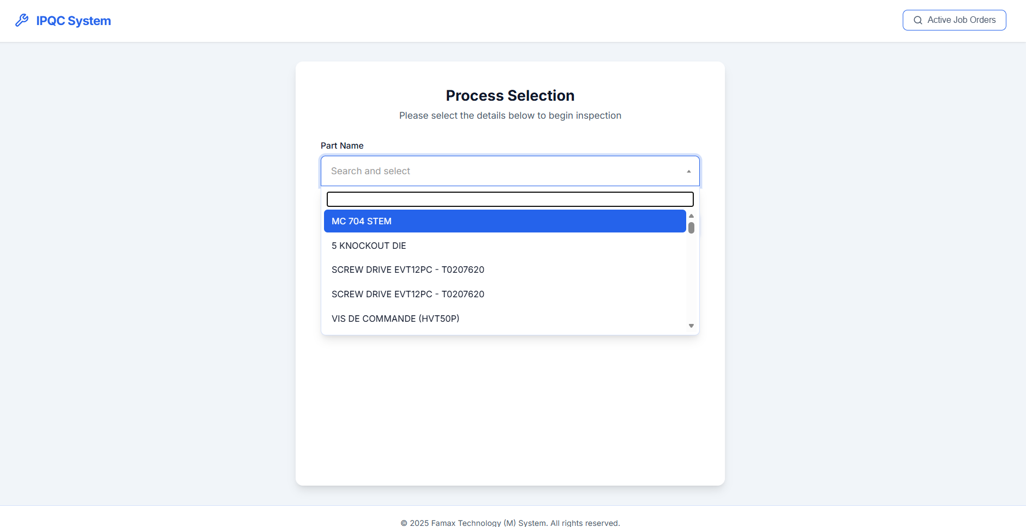
  - Then all IPQC process related to the part chosen will be shown. Select the process.
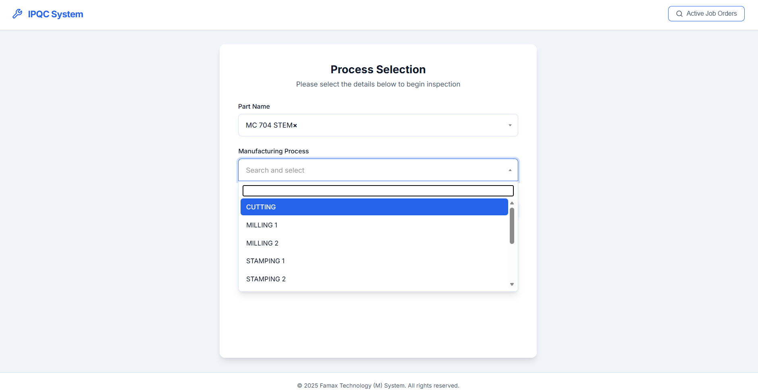

- Then, system will ask for JO Number and select machine number from the dropdown and click “Continue” button.
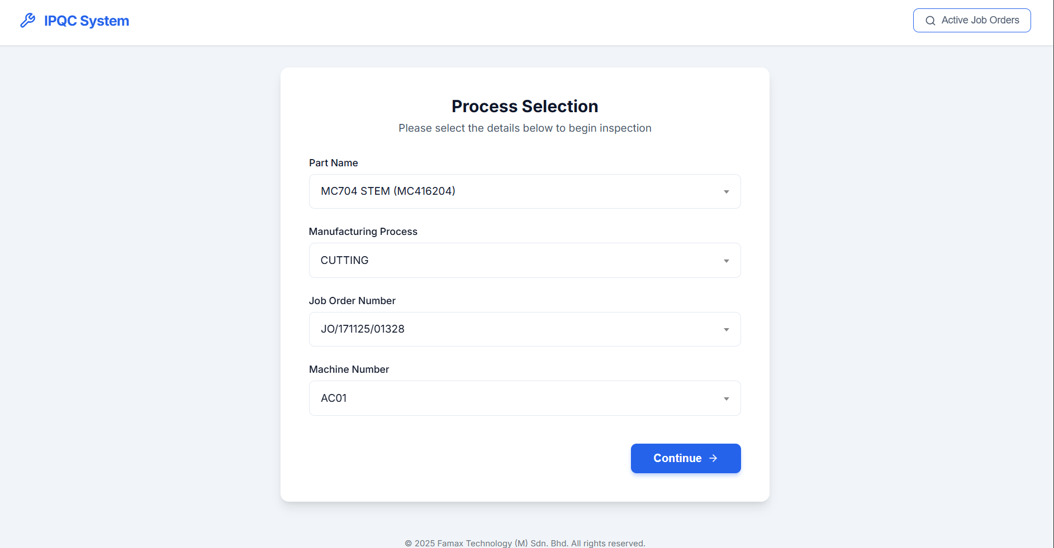
- This will be the screen after clicking “Continue”.
  - Fill in the checker’s name in the first red box
  - Fill in the reading for each zone.
  - After that click next to process.
Note : Wrong values would prompt telegram alert, so make sure take correct reading.
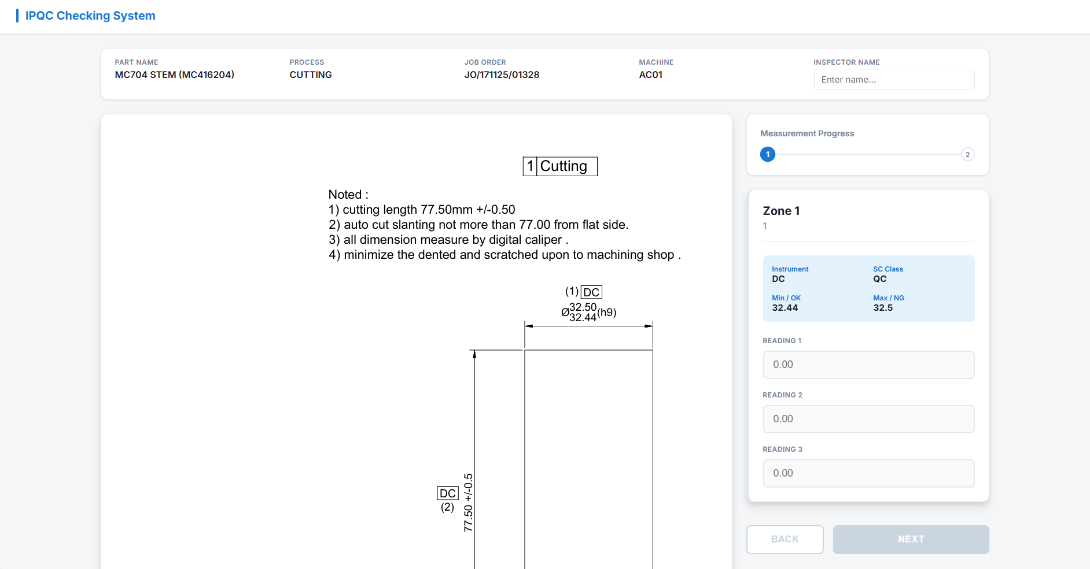

  - Complete all reading zones and click submit all reading buttons.
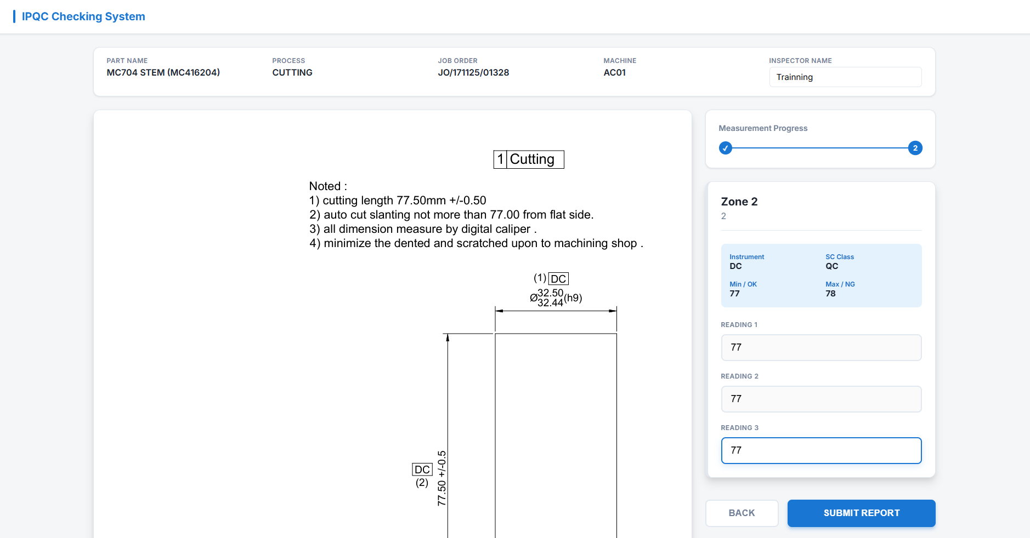

- Message will prompt out if there is out of spec measurements and this will notify management.
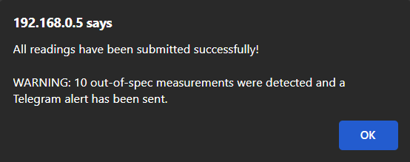

- You will then be redirected to summary page where you can see the wrong readings. The red column shows wrong reading, so take necessary action like informing technician or engineer.

  - Click on “Finish Report” button

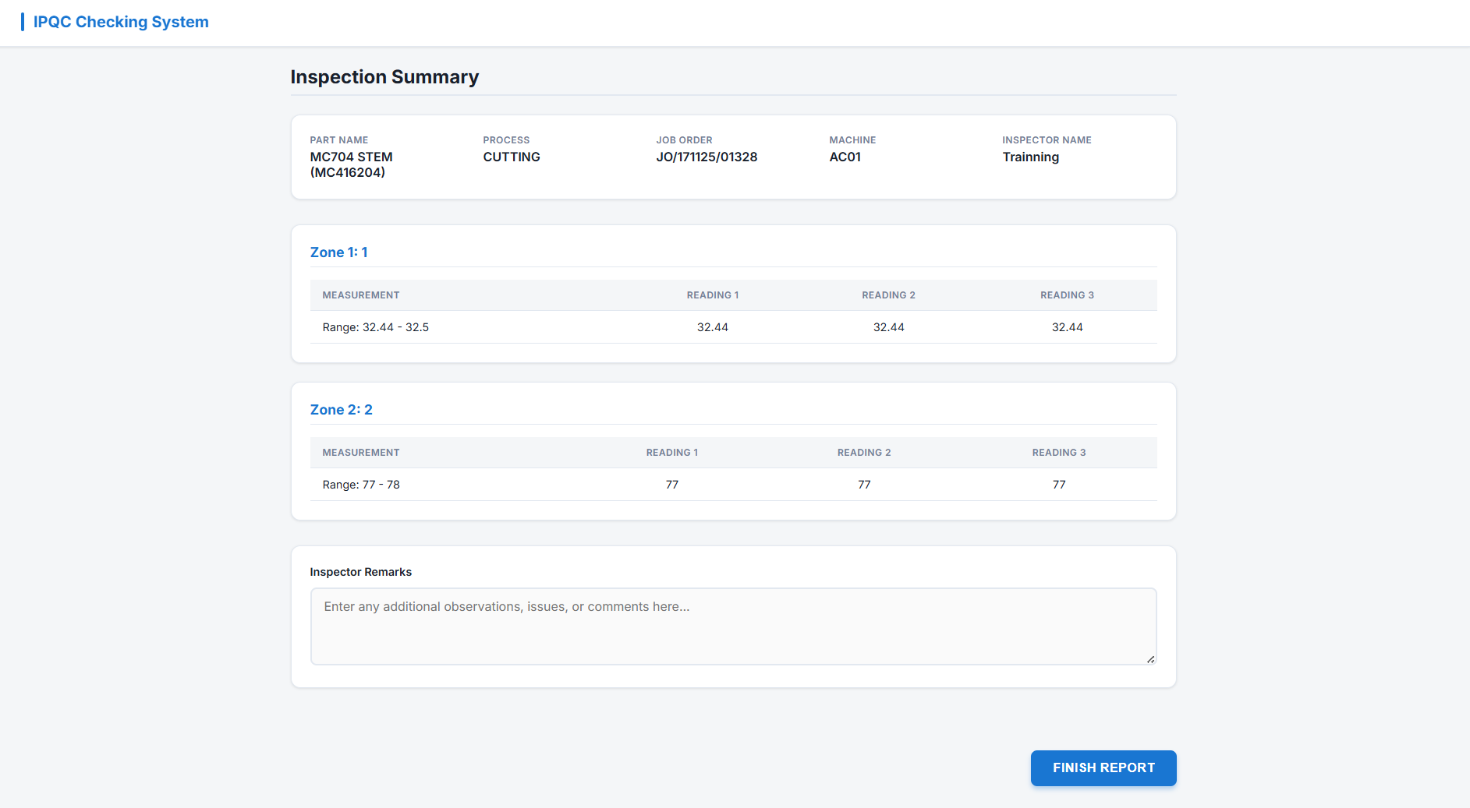

- It will return to the main page.

- All process is the same for IPQC, IQC and OQC but for IQC and OQC have and button “Inspection Guide”. If click that button, then you can straight view inspection guide if you have anything to refer.

USER GUIDE BY ROLE ACCESS

- There is a login button. Click the button. This is accessible with credential only.
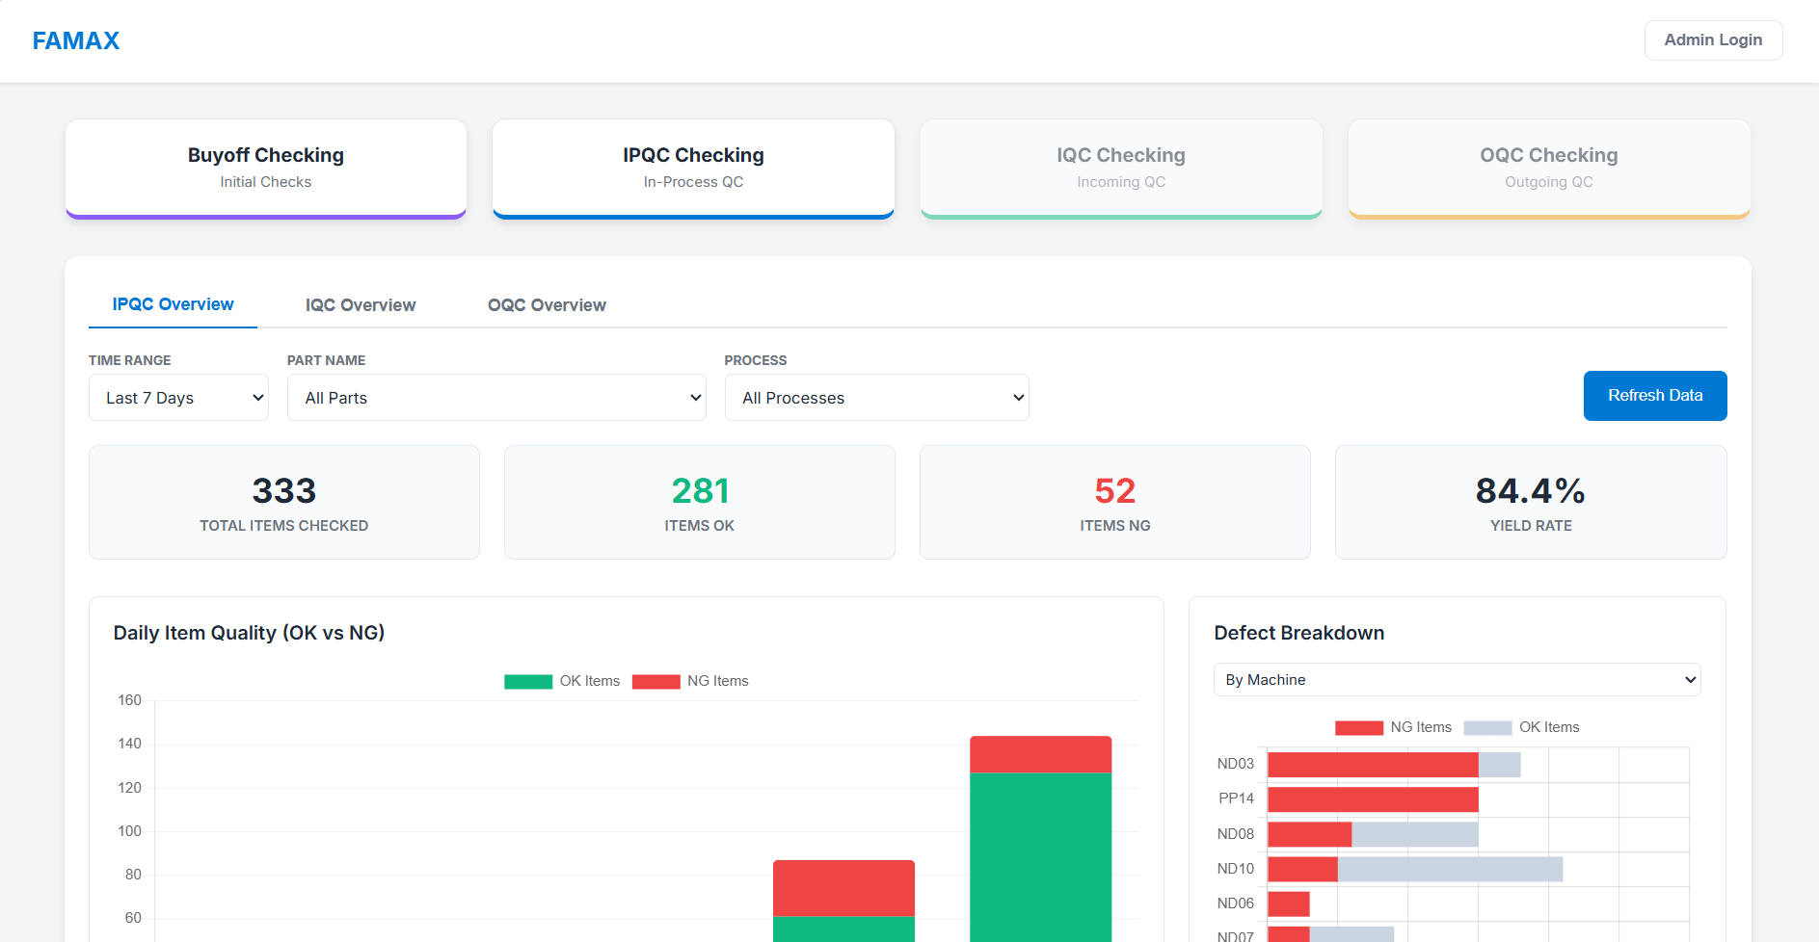
- Click “Login” and it will be prompt this box.

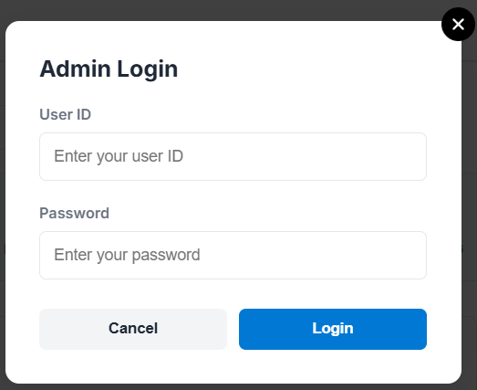

  - Below shows images of access level.
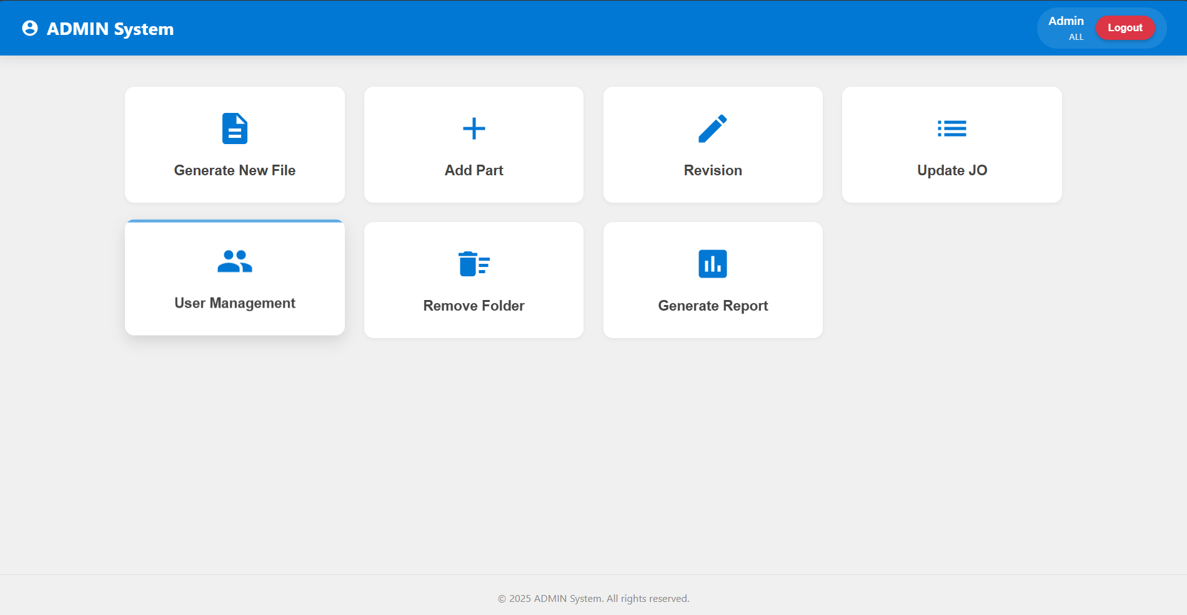
All access has no buttons blocked. Only administrators are allowed to access all functions.

ENGINEER ACCESS
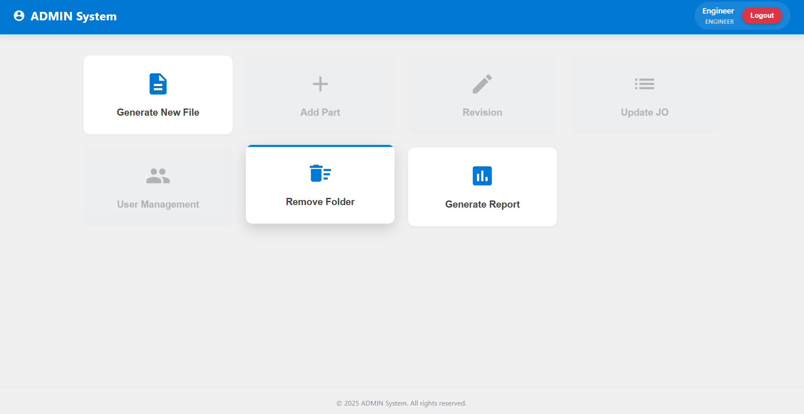
ENGINEER access can only access Generate New File, Remove Folder.

- Now, when you click “Generate New File” button. You will get a page as below.
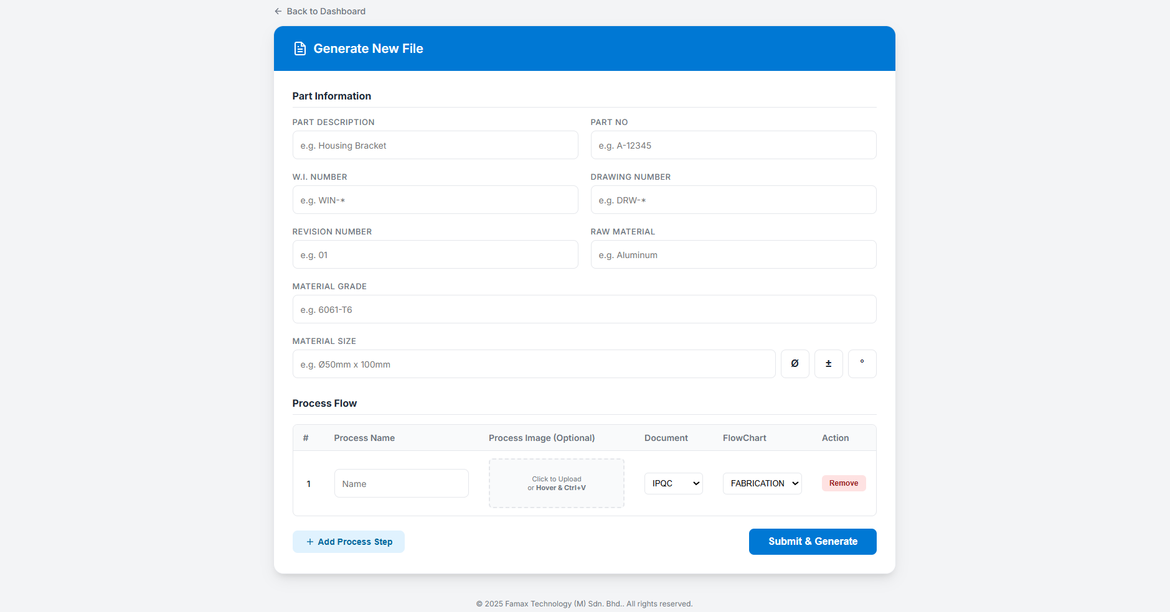
- Make sure all cells are filled and all process is determined before generating document for the process.
DO NOT USE process name as: Milling (M1). Avoid bracket.
Then click submit button.
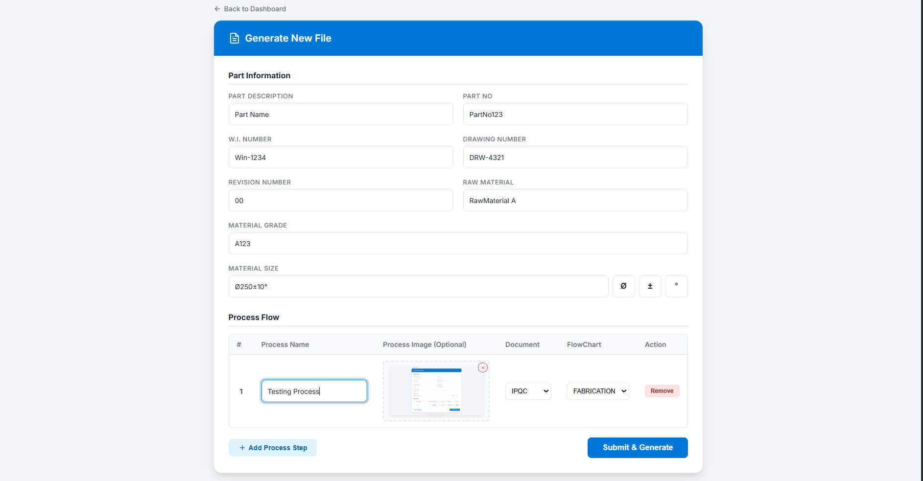

- Page will be auto redirected if there is no error occur. Fill in everything properly and click submit. Once click submit wait patiently as it may take some time. Wait until the pdf saved message pops out successfully. If anything, error please inform IT department immediately. Do Not RETRY

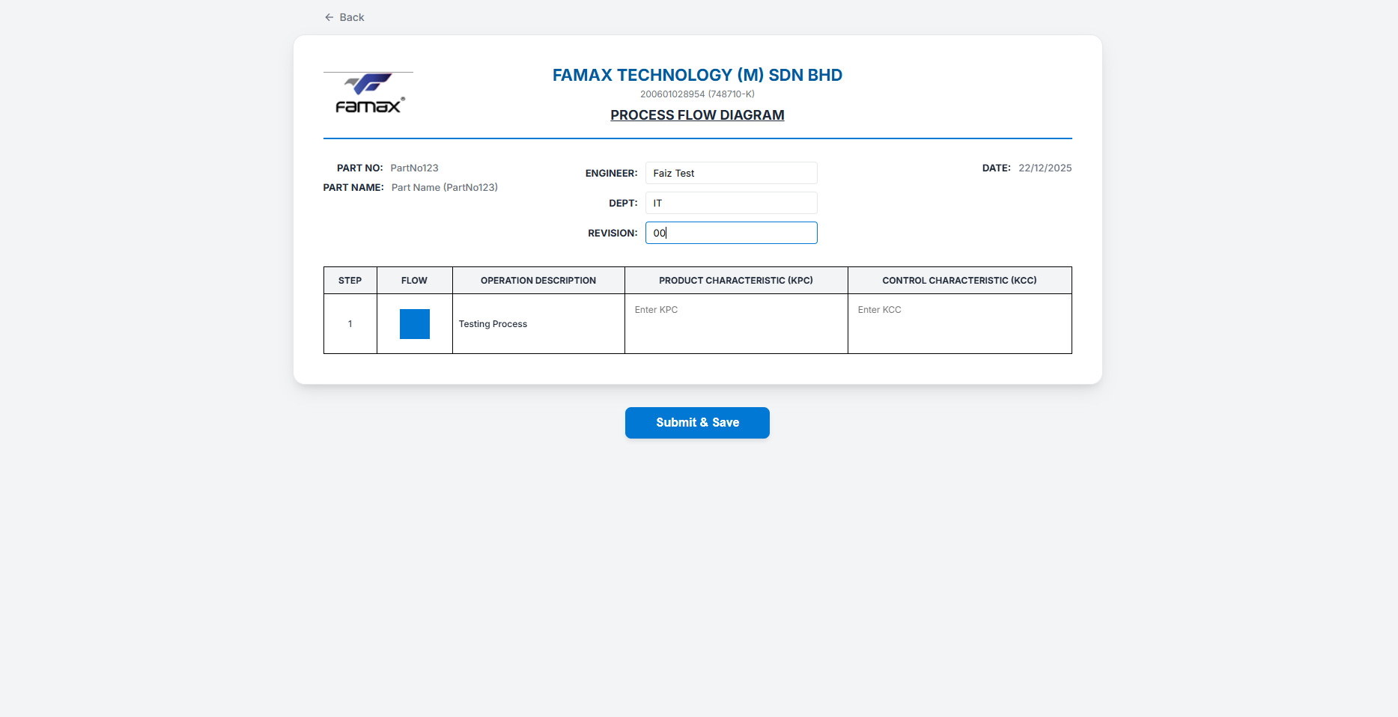

- The page will be redirected to Admin Home Dashboard.

REGISTER ACCESS
- Now, let’s move to “Add Part” Button. This part is done by Register only after all documents are done properly.
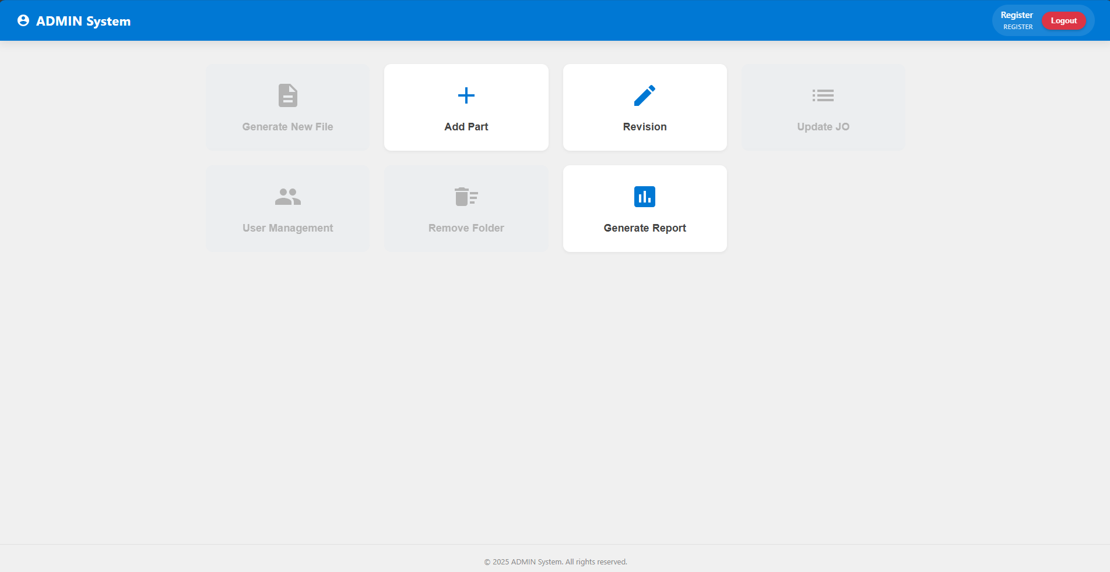

- Choose the part name. We will do for “Part 1A” now.
  - Select Part Name from dropdown field.
  - Choose folder that contains all Excel files.
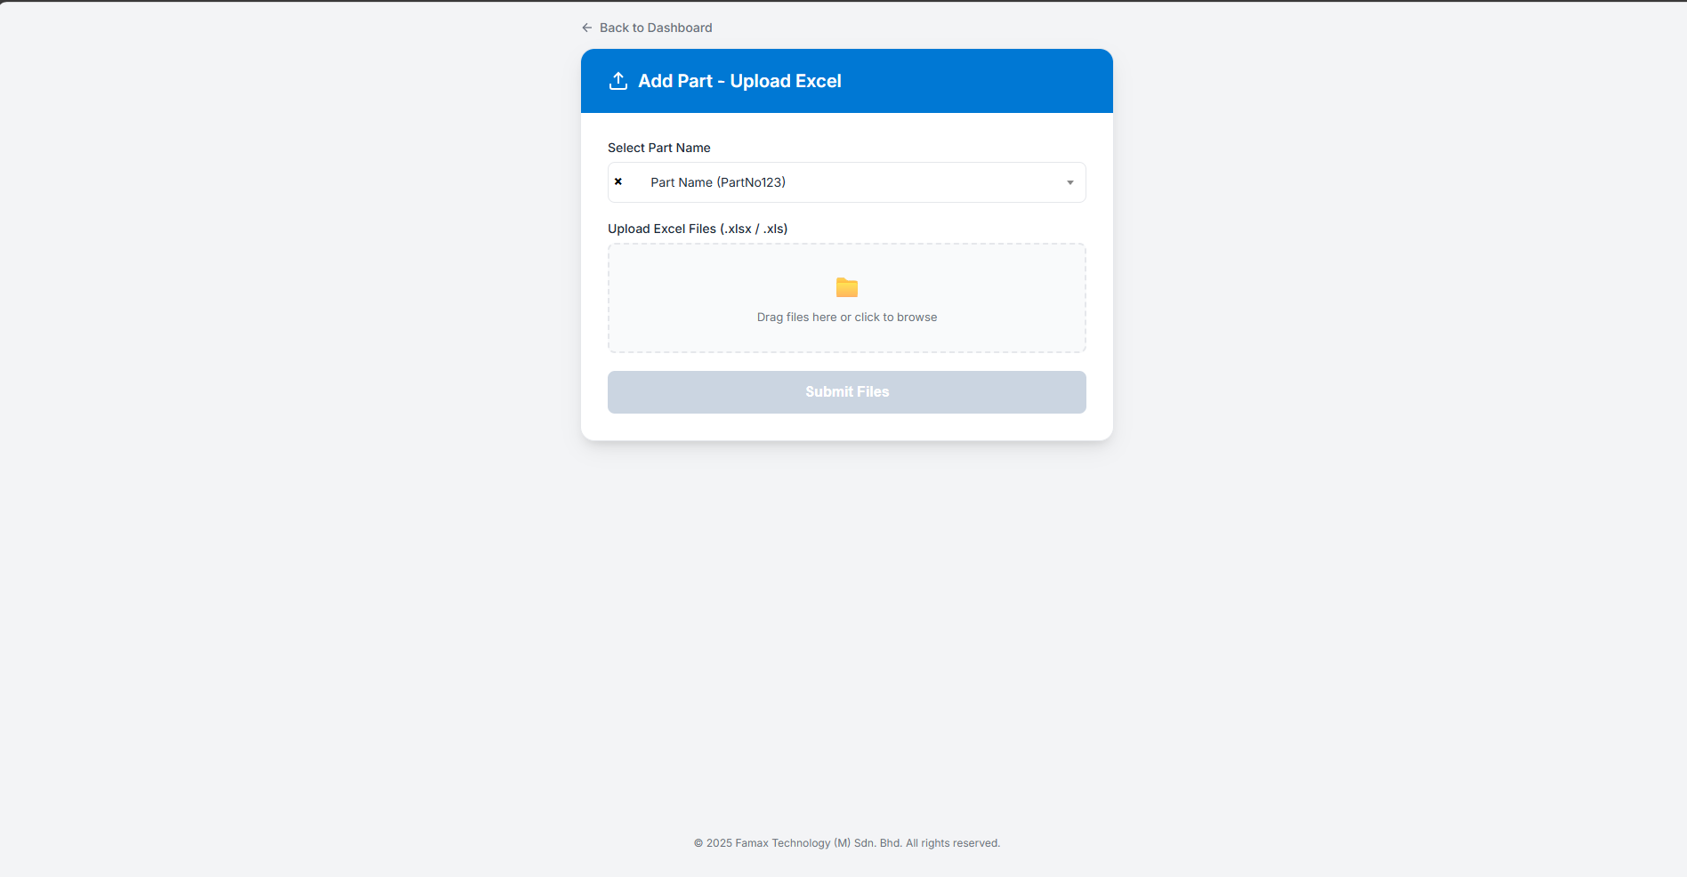

- Upload the completed folder that contains all excel files.
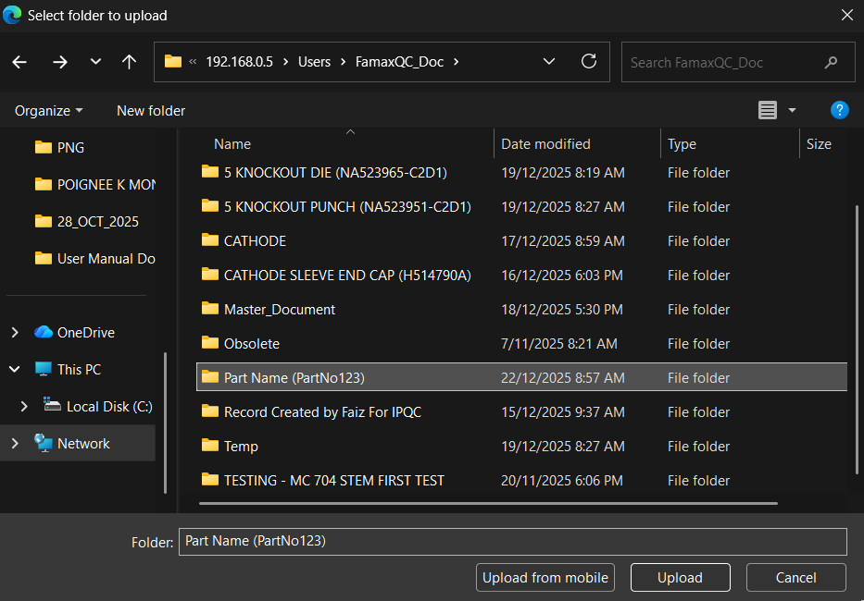

- Do not disturb the setting as all will be detected automatically. And then click “Submit Folder” button.
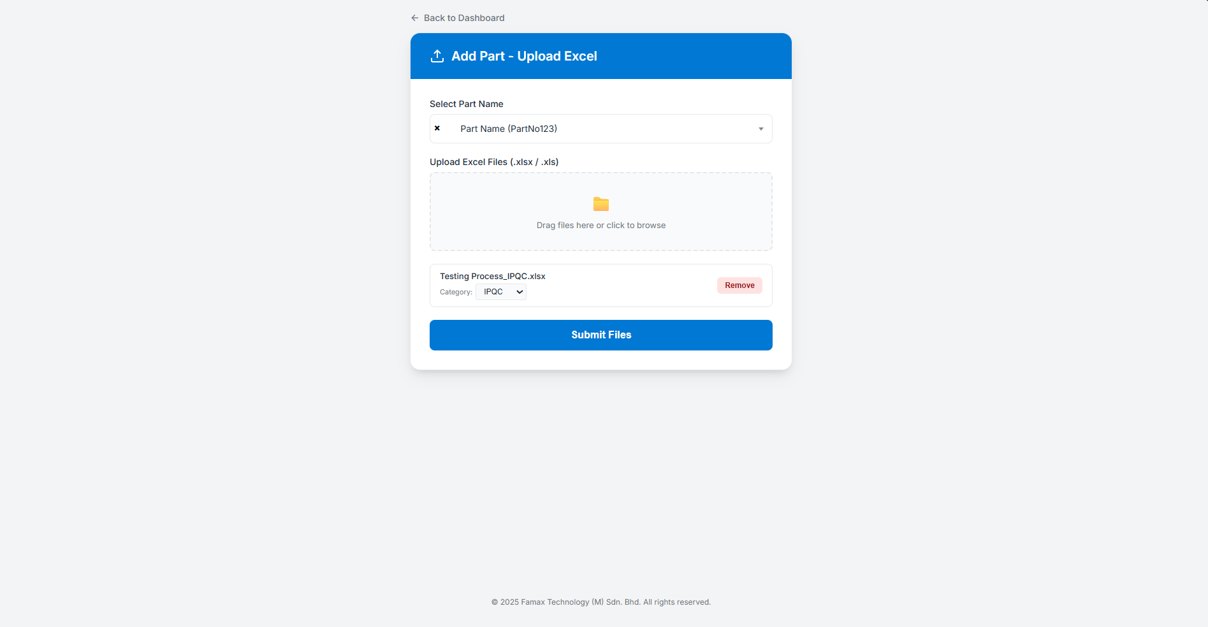

- After uploading the folder consist of excel, the system will redirect to this page. Please upload the image folder consist of the product process image.
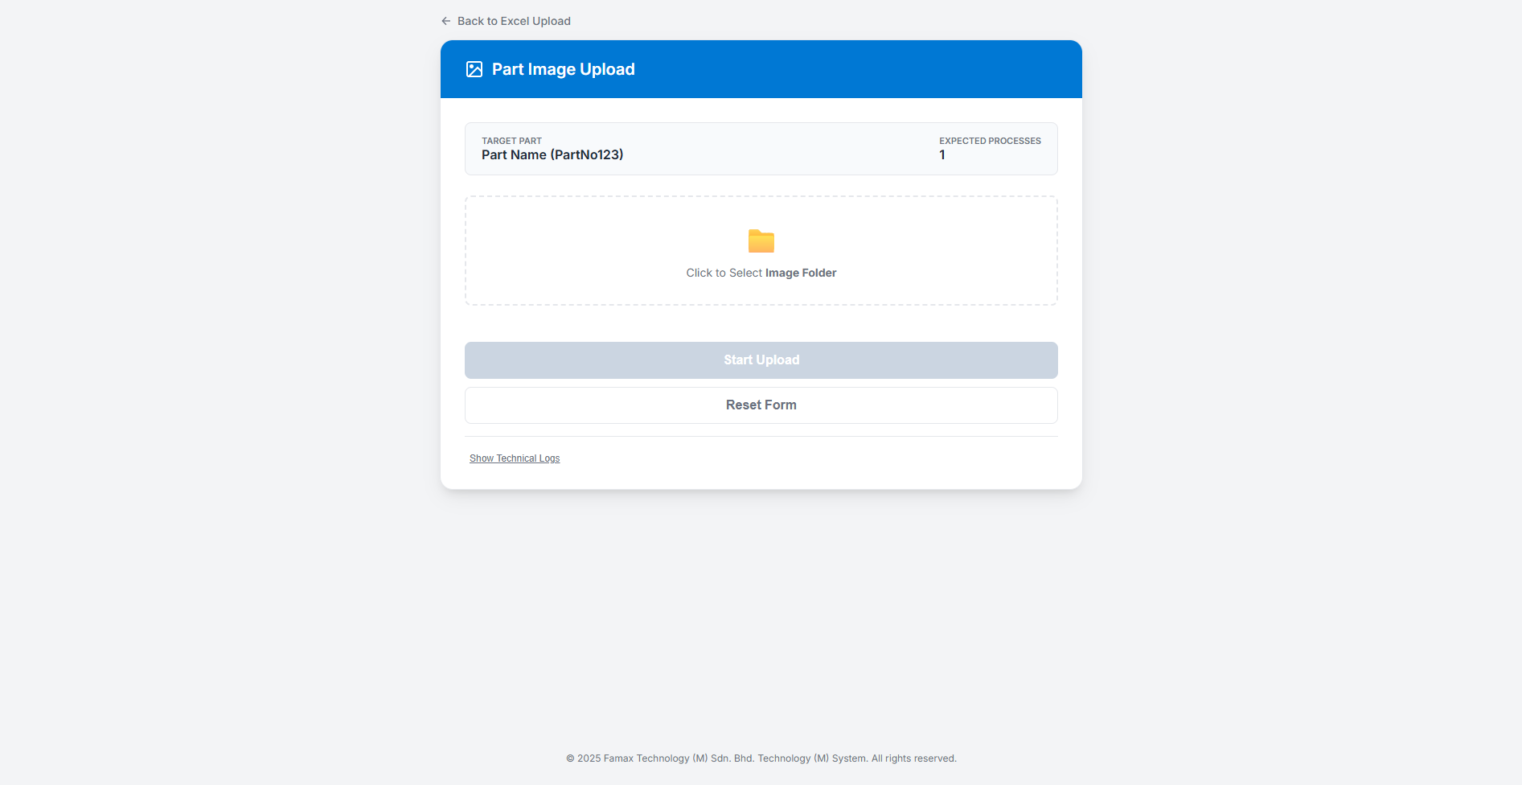
- Here you must add folder containing all images. Image name and Process name must match. IQC and OQC must add pdf of Inspection guide as well. Then, click “Start Upload” button. Make sure no errors, if ERROR report immediately.
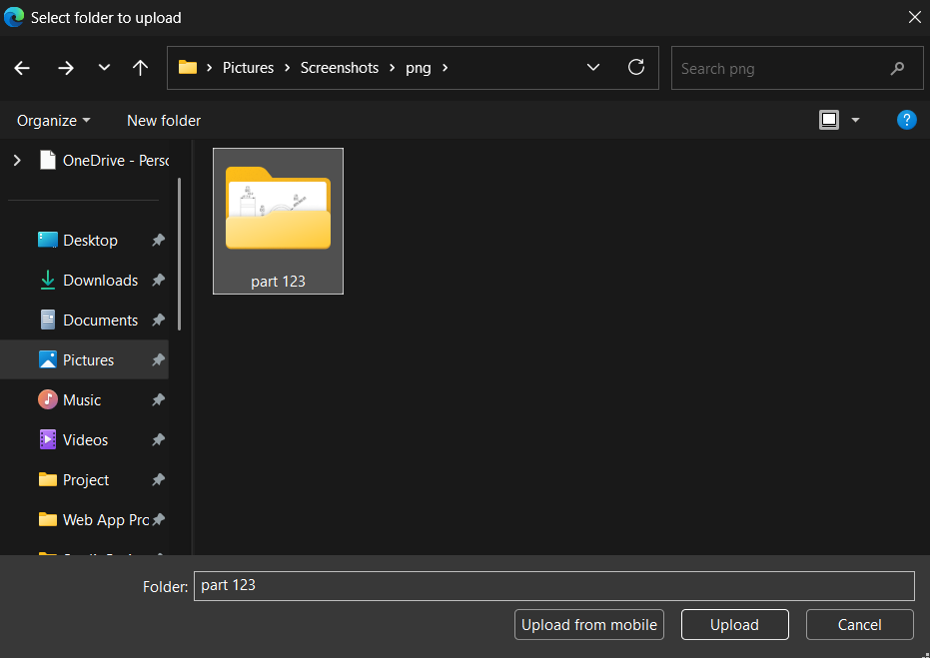

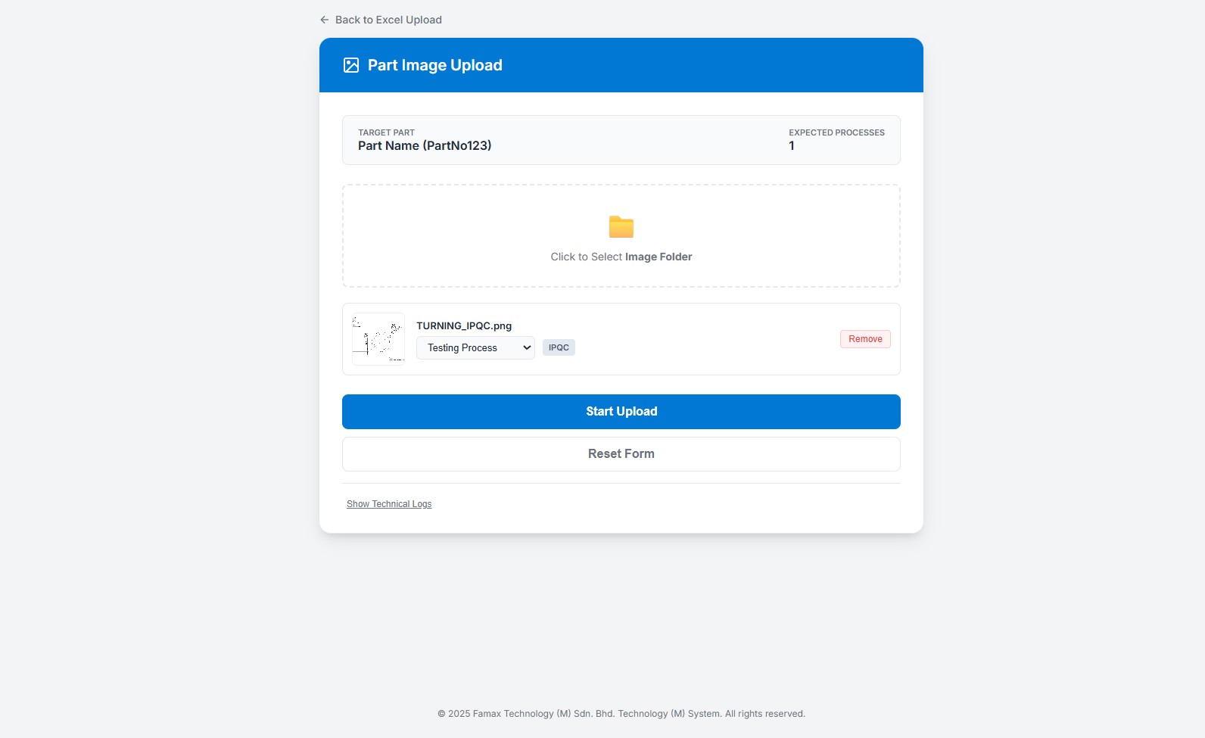

- If folder successfully uploaded, user will be redirected to Admin Home Dashboard.
- Next, is for “Revision” button.
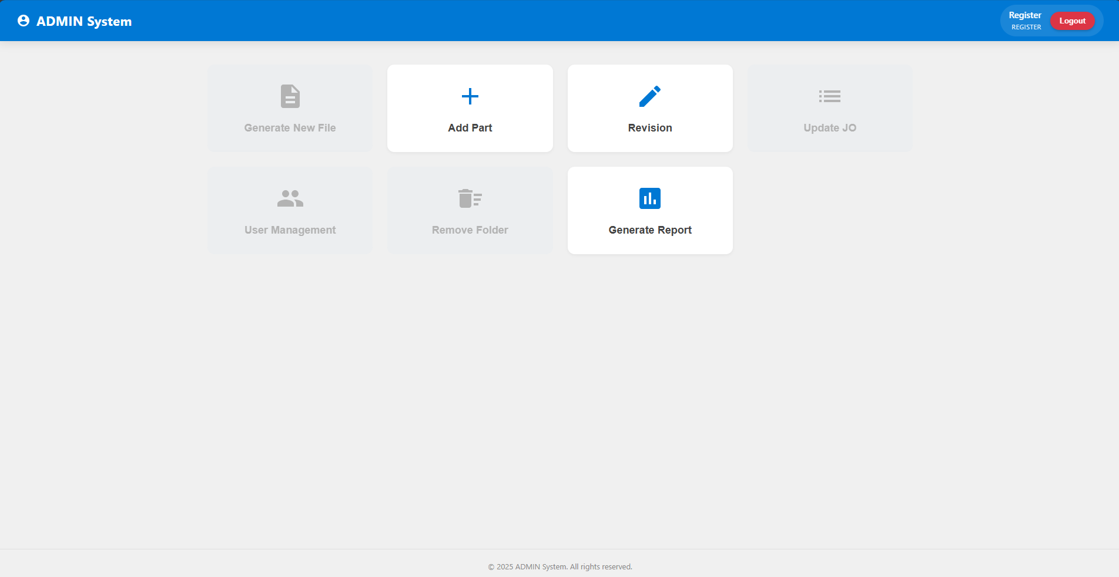

- Once this button is clicked, select the Document Type > Part Name > Process. Process related only will be shown as dropdown option.
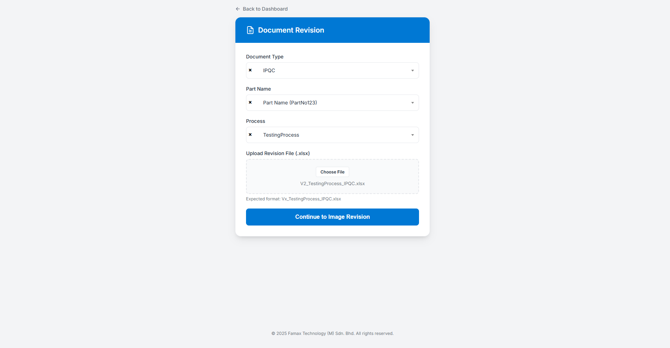

- Once you have chosen the process you must upload the latest excel file. The file naming must be controlled. So the latest file must be Vx_Milling 1_IPQC.xlsx. Let’s say document is use is V2 the latest one must be V3.
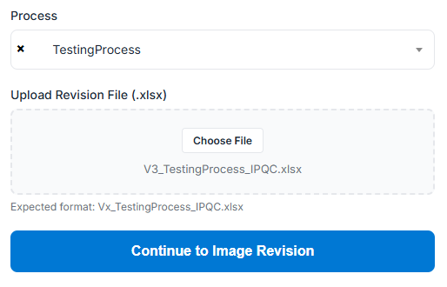
Example Filing Name

- Then, click “Continue to Image Revision” button. You will redirect to the next page to upload the image. Only one image can be uploaded. If “IQC” document or “OQC” document the must upload pdf as well. Then, click “Complete Revision” button.
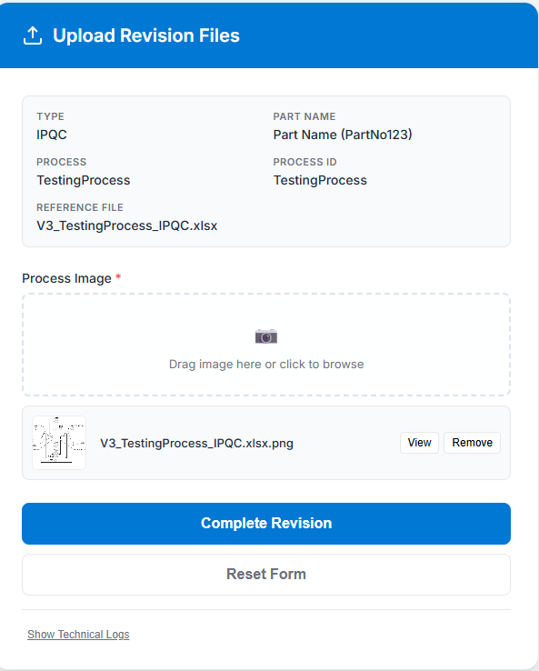

- After the process is complete, it will redirect to the Admin Home Dashboard.
- Finally, for Register Access, user can generate report.
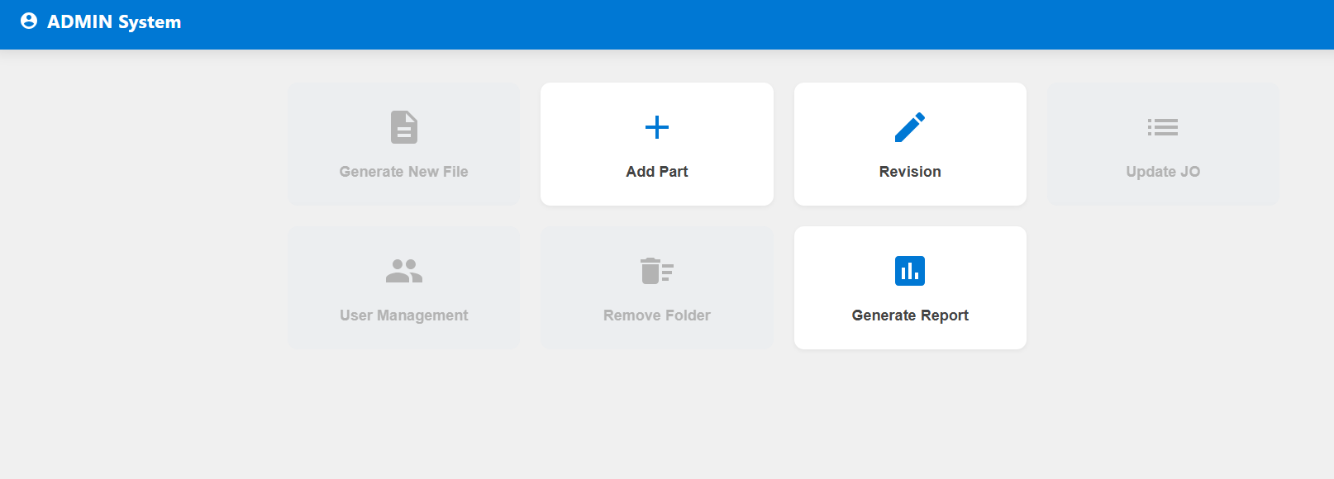

- Generate report consists of 2 types of generated report.
  - By Parts.
  - All Parts.
- By Parts, users can generate reports by choosing Daily, Weekly or Monthly Reports.
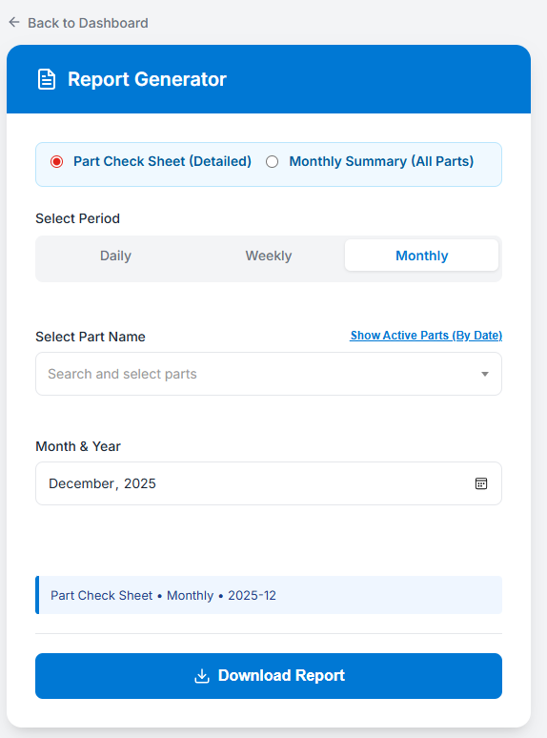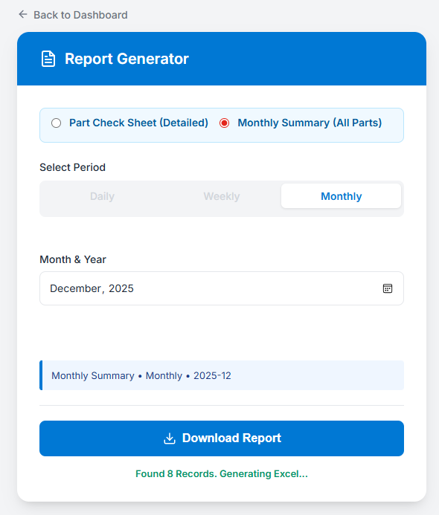
- Users can see the list of Active Part/Part Number that have been inspected by date, default date (today) if the click “Show Active Parts by Date”.
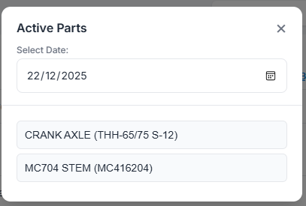

- When user selects part name, and date to generate report. User need press enter or “Download Report”.
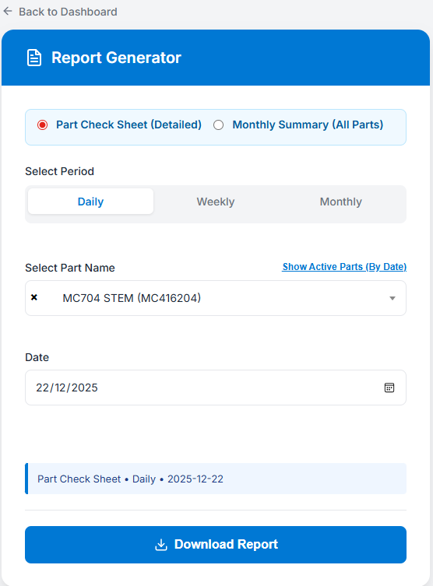
- Download box will be appear on the right top corner of the browser. (Current shows: Microsoft Edge Browser).
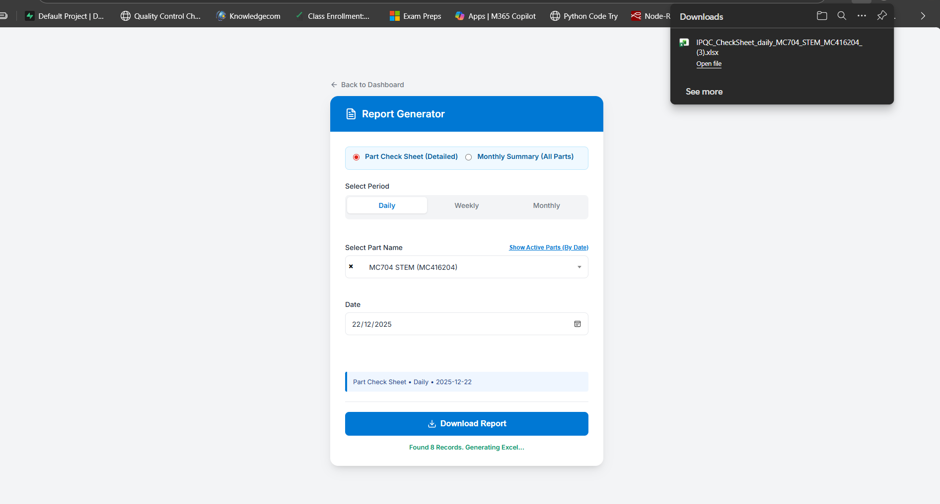

PRODUCTION ACCESS
- Production can only access “Update JO” button.
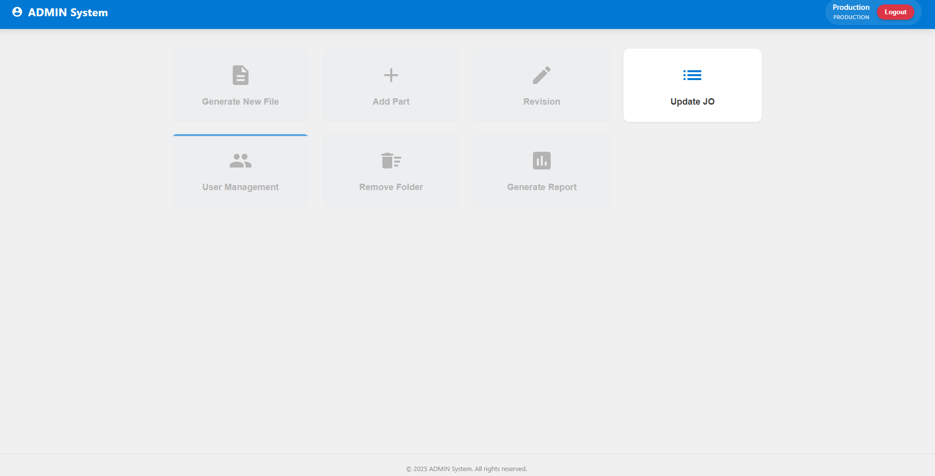
- This is the Update Job Order Page. Users will see at 3 tabs consists of “Update Jo”, “Create New” and “History”. The default page is Update JO tab.
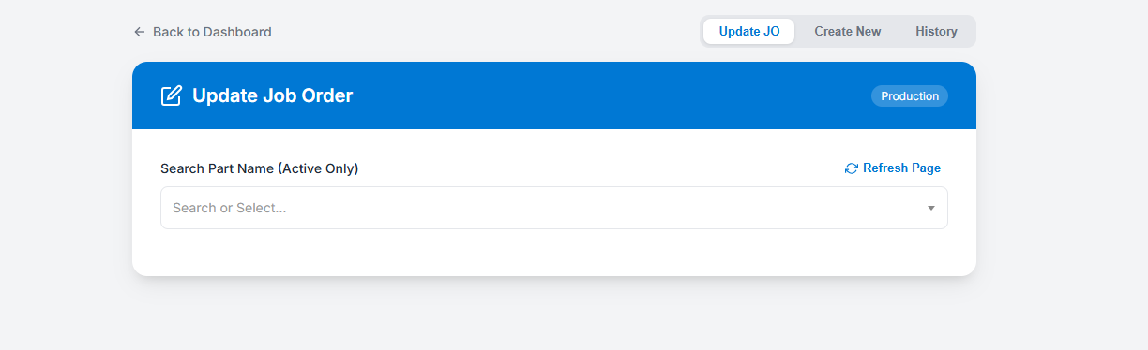

- If users enter the Part Name, the list of current production jobs will be listed.
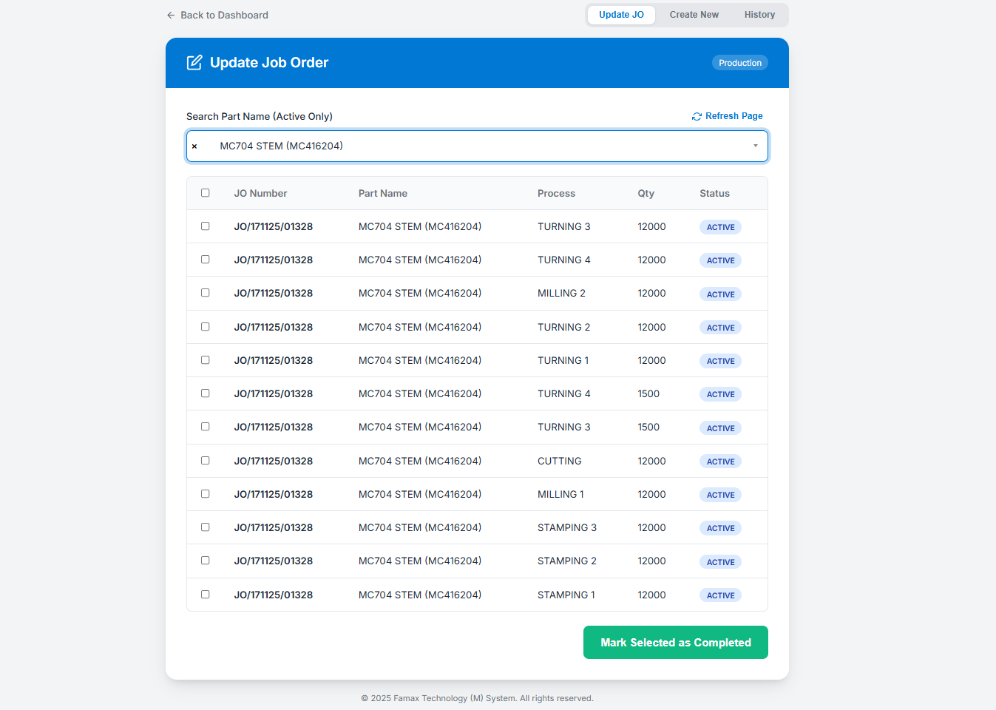
- To create a new Job Order, users need to choose to create new tab on the top right of the page and field all the required details. Each process needs to be created for each part name and click “Create Job Order”.
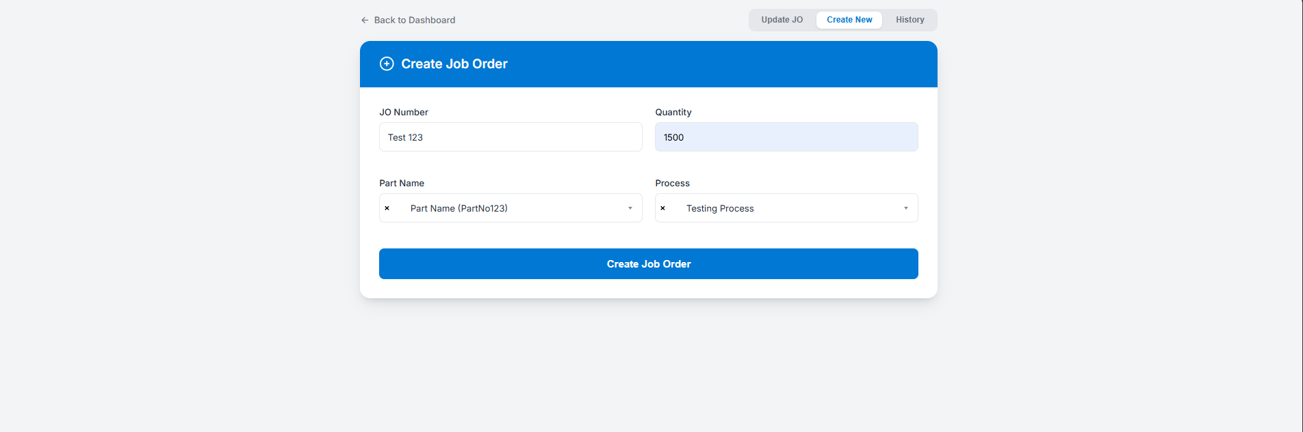

- Click “Confirm” to confirm Job Order creation.
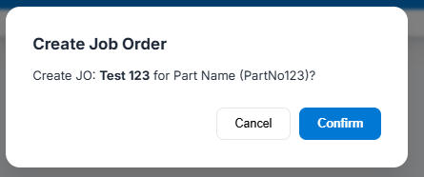

- If the job is completely produced, users need to mark the process for the job order to be complete.
  - First, select the process using the checkbox.
  - Click “Mark Selected as Complete”.
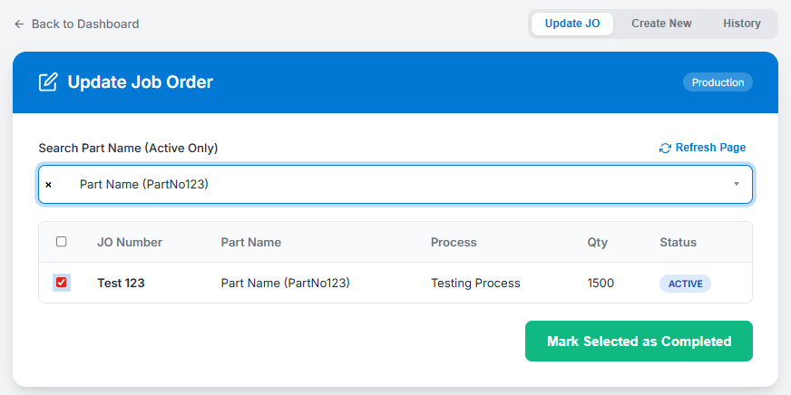

- To see the history jobs order, User can go to the History tab in the top right corner of the page. Users can search the page using search field with JO Number and Part Number.
